**Database Practical Week 9**

# **Practical 9**

INDADD 2014/2015  
Introduction to Database Analysis and Design  
School of Computing  
Week 9: SQL Implementation

Top of Form

## Part I: CW support

The 1st CW submission is next week (Week 10), so this might be your last chance to get feedback on your ERD. Task 1: Using suitable software (e.g. Visio), create an ERD for your system showing: entities and their attributes primary and foreign keys the types of relationships between entities (cardinality) [10 Marks]

## Part 1: Database Implementation

A step by step guide on how to create tables and insert data is available under the following link: [https://drive.google.com/file/d/0B2_t9aZ197ElR0twMmJLdGVyUms/view?usp=sharing](https://www.google.com/url?q=https://drive.google.com/file/d/0B2_t9aZ197ElR0twMmJLdGVyUms/view?usp%3Dsharing&sa=D&usg=AFQjCNGSSx-K3JCcOuC-1MGlzf8D83WF2A) When using your personal VM server: instructions for accessing the MySQL database on your personal server are at: [https://docs.google.com/document/d/1zqvC5jOoXQlXggKZkEC025H-N6k7HxdTHpsy0Iylt0c/edit?usp=sharing](https://www.google.com/url?q=https://docs.google.com/document/d/1zqvC5jOoXQlXggKZkEC025H-N6k7HxdTHpsy0Iylt0c/edit?usp%3Dsharing&sa=D&usg=AFQjCNHl78eNsQ6e0XiVERcqybperRc4ng) Below is the ERD for Scenario 4 Week 5. Your task today is to implement the ERD using SQL. Study the ERD and answers the question bellow. The Hudson Engineering Group (HEG) has contacted you to create a conceptual model whose application will meet the expected database requirements for the company’s training program. The HEG administrator gives you the description (see below) of the training group’s operating environment: The HEG has 12 instructors and can handle up to 30 trainees per class. HEG offers five “advanced technology” courses, each of which may generate several classes. Each class is taught by one instructor. Each instructor may teach up to two classes or may be assigned to do research only. Each trainee may take up to two classes per year.

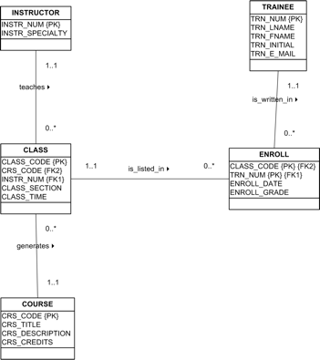

**Question 1:**

Write below the SQL code to create table COURSE. Then implement the table on MySQL server.

mysql> CREATE TABLE COURSE

-> (

-> CRS_CODE int,

-> CRS_TITLE varchar(40) not null,

-> CRS_DESCRIPTION varchar(500) not null,

-> CRS_CREDITS int not null,

-> primary key (CRS_CODE) );

**Question 2:**

Write SQL command to insert a few records into table COURSE. Use the units that you are doing this year as the data source (e.g. INDADD, WEBFUN etc.)

mysql> insert into COURSE values(1,'INDADD','DATABASE',20);

**Question 3:**

Write a SQL query to display all the records in table COURSE.

mysql> SELECT * FROM COURSE;

**Question 4:**

Write below the SQL code to create table INSTRUCTOR. Then implement the table on MySQL server.

mysql> CREATE TABLE INSTRUCTOR

-> (

-> INSTR_NUM int,

-> INSTR_SPECIALITY varchar(40) not null,

-> primary key (INSTR_NUM)

-> );

-> primary key (CRS_CODE) );Bottom of Form